To: Members of Waterford, Simcoe and Port Dover Minor Hockey Associations

From: Mrs. Shelley Miles, President – Waterford & District Minor Hockey Association
Mr. Pat Meahan, President – Port Dover Minor Hockey Association
Mr. Martin Jefferson, President – Simcoe & District Minor Hockey Association

Dear Waterford, Simcoe, and Port Dover Minor Hockey Members,

As we commence the 2019/2020 Hockey Season, the Executives of Waterford, Simcoe, and Port Dover Minor Hockey Boards have endorsed the continuance of negotiations regarding the creation of a jointly operated Representative Hockey Program for the benefit of all minor hockey players in our area.

We are pleased to report that a negotiating committee has been established and are working extremely hard; reflecting on last year’s discussions, progress/challenges, making adjustments to the proposal and perhaps most of all – improving our communications to you on matters (like this) that require your consideration and input. We will also strive hard to answers the many questions you may have.

To move forward in a transparent and informed manner, some foundational principles have been set out by the negotiating committee working on this proposal:

- Ensuring that changes proposed at the REP level have little to no impact to the Hometown Local League hockey structure
- Clarifying why these changes are being considered for REP level hockey
- Improved communications to all of our members on this proposal
- Securing and providing answers to the many questions you have IN ADVANCE of any vote on this proposal so that you can make a well-informed decision

PRINCIPLE 1 – No change where change is not necessary
The vast majority of our players play at the recreational Local League level. Last year’s information sessions highlighted the fact that these players/families wished to see no changes within this level of hockey. With that in mind, the negotiating committee will ensure that this takes place. For these players and families, no changes are proposed and they will continue to receive the community-based hockey experience that they have come to appreciate. Local League players will continue to proudly wear their Wildcats, Warriors, and Pirates sweaters, will continue to play within their local community rink, and will continue to play and develop with their friends as part of the overall Local League hockey program. The modified proposal will ensure we maintain the “hometown hockey” experience our members value and expect.

PRINCIPLE 2 – Clarifying Why
Our top priorities are player development and fun. Player development and fun are best achieved when players play at the level of hockey that meets their needs (Local League, AE, or REP) and alongside other players that have the same and/or similar skills and ability.

With declining player enrollment, our associations have all struggled to offer a full range of hockey programming (Local League, REP and AE) in a consistent manner across all divisions. Consequently, our associations see players play at levels of hockey above and below their needs and with teammates with abilities that are far superior or inferior to their own. When this happens player development and fun suffer.

By working together through a Rep partnership arrangement, we can provide a more complete and sustainable hockey program. We can do this without interfering with or modifying our local league structures. Local league hockey will remain as it currently operates; those seeking more competitive/skilled hockey would have a combined REP level hockey program to play in. This program seeks to offer “A” major/minor REP and AE divisions from a combined talent pool that will result in improved consistency in player ability within each team, and see those teams playing comfortably at an appropriate level of competition.

This much-improved hockey program cannot be offered by any of our associations alone. By working together at the Rep level, we will be able to deliver a broader spectrum of hockey programming for the benefit of all players.

PRINCIPLE 3 – Improved Communications
This communication is one of many that will be shared with you as this proposal develops over the coming months. We have established an @NorfolkMinorHockey facebook page to provide our members a direct way of keeping informed in a timely and coordinated way. Each participating association will also post articles and links on their respective web-page that will point you to @NorfolkMinorHockey. Each participating Board Member is well informed on what is going on and will be able to point you to where you can find out more information – should you be searching for information. We are planning for our first Members Information Meeting and will advise members shortly on a meeting dates once set. Stay tuned. Stay tuned for information.

PRINCIPLE 4 – Have answers to your questions
The best votes come from informed voters. When voters have unanswered questions, the tendency is to vote for “status quo”. We will strive to answer your questions well in advance of any vote on this proposal so that you can properly consider this proposal. We acknowledge that not every question will have an answer, but when that is the situation, we will explain why and how/when we expect to be able to address it.

THE GOAL AND DRAFT ORGANIZATIONAL STRUCTURE
Our goal is to develop a Hockey Association framework that provides improved hockey development opportunities within a structure that preserves the local community identify that we all value.

The proposed framework model will preserve the original Minor Hockey Organizations within our area, allowing Waterford Minor Hockey, Simcoe Minor Hockey, and Port Dover Minor Hockey to continue in celebrating their community identities with local hometown teams at the recreational level – where the Local League teams will be able to continue their rich community histories and traditions, within the framework of a new cooperatively-run organization. Norfolk County Minor Hockey created by the Local Minor Hockey Associations whose sole purpose is to run and manage the representative component of the Minor Hockey Program.

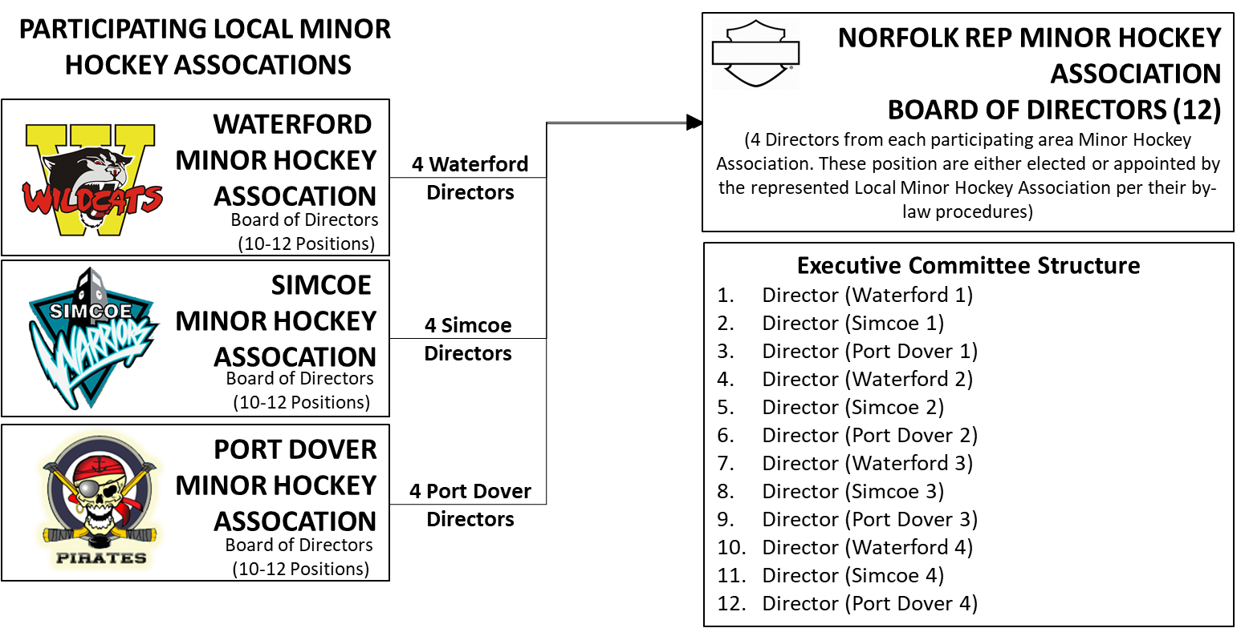
Figure 1 “DRAFT Organizational Concept” for Preserving all existing Minor Hockey Associations and Creating a 4th entity – Norfolk REP Minor Hockey

As set out in Figure 1 above, the Draft Rep Hockey organization would be operated by a jointly administered Board of Directors, appointed by Waterford, Simcoe, and Port Dover Minor Hockey Associations.

We strongly believe that this partnership of equals will achieve the best of both worlds in terms of preserving and celebrating our traditional Hometown Hockey identities at the Local League level, while allowing us to build a stronger, more dynamic and competitive Rep Hockey Program that will benefit all players within our participating organizations.

More information about this proposal will be communicated to you over the coming weeks and months as the negotiating team continues to pull this proposal together. Please forward any questions, comments, or concerns to the attention of your organization’s President.

Sincerely,

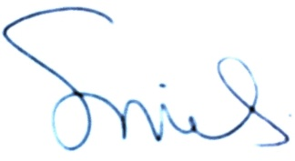 |  | 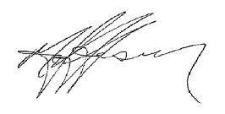 |  | 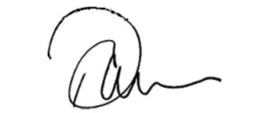
Mrs. Shelley Miles |  | Mr. Martin Jefferson |  | Mr. Pat Meahan
President, |  | President, |  | President,
Waterford & District Minor Hockey Association |  | Simcoe & District Minor Hockey Association |  | Port Dover & District Minor Hockey Association
“Our intent is to collaborate, develop and present an opportunity to improve hockey in each of our centers and for every child that chooses to step on the ice, to learn and play hockey. It needs to be positive and meaningful for every child at every level – and that is our goal.”

